**Due Diligence Automation System**

**Troubleshooting Guide**

Revision 2

21-June-2018

Developed by:

Clarity Information Technologies Pvt. Ltd.

Bangalore.

Tele: 080 - 2529 1698

**Email:** [**mail@claritytechnologies.com**](mailto:mail@claritytechnologies.com)

Table of Contents

Revision History 3

Introduction 3

1 Application Environment 4

*1.1* *Application Architecture* 4

*1.2* *Application Servers* 5

1.3 *Database Servers* 5

1.4 *System Functions and or Services* 6

1.5 *Backups/Restores* 6

2 Support Procedures 6

2.1 *Common Problems/Troubleshooting* 6

Data Extraction Error: 7

Annexure: 9

1. FDA Debarment List 10

2. Clinical Investigator Inspection List (CLIL)(CDER) 11

3. FDA Warning Letters and Responses 11

4. Notice of Opportunity for Hearing (NOOH) – Proposal to Debar 12

5. Adequate Assurances List for Clinical Investigators 13

6. Clinical Investigators – Disqualification Proceedings (FDA Disqualified/Restricted) 13

7. Clinical Investigator Inspection List (CBER) 14

8. PHS Administrative Actions Listing 14

9. HHS/OIG/ EXCLUSIONS DATABASE SEARCH/ FRAUD 14

10. HHS/OIG Corporate Integrity Agreements/Watch List 15

11. SAM/SYSTEM FOR AWARD MANAGEMENT 16

12. LIST OF SPECIALLY DESIGNATED NATIONALS 17

# [1]

# Revision History

|  |  |  |  |  |
| --- | --- | --- | --- | --- |
| **Date** | **Version** | **Section** | **Description** | **Author** |
| 19-June-2018 | 1.0 | All | Initial | Pradeep / Johnly |
| 21-June-2018 | 2.0 | Application Architecture | Updated | Pradeep / Johnly |
| 21-June-2018 | 2.0 | Header | ICON Logo – replaced. |  |
|  |  |  |  |  |
|  |  |  |  |  |
|  |  |  |  |  |

# Introduction

DDAS is a Web Application and can be accessed through: **http://ddas.iconplc.com** and **http://ddastest.iconplc.com**

The main goal of the DDAS application is to aid the user to collate Investigator and Institute related Complaince Issues into Investigator Compliance Search Forms (ICSF).

The application collects Investigator Compliance related data from various pubic sources. The application downloads this every 24 hours and converts it into data repositories.

The application user inputs details such as Project Number, Name of Institute, Country, List of Investigators and their Role, Prinicpal or Sub. The application scans through the latest version of the data repositories for suitable match of Invesigator Name and presents the results to the user for recording observations.

The data is extracted from the following web sites –

1. FDA Debarment List
2. Clinical Investigator Inspection List (CLIL)(CDER)
3. FDA Warning Letters and Responses
4. Notice of Opportunity for Hearing (NOOH) – Proposal to Debar
5. Adequate Assurances List for Clinical Investigators
6. Clinical Investigators – Disqualification Proceedings (FDA Disqualified/Restricted)
7. Clinical Investigator Inspection List (CBER)
8. PHS Administrative Actions Listing
9. HHS/OIG/ EXCLUSIONS DATABASE SEARCH/ FRAUD
10. HHS/OIG Corporate Integrity Agreements/Watch List
11. SAM/SYSTEM FOR AWARD MANAGEMENT
12. LIST OF SPECIALLY DESIGNATED NATIONALS

# Application Environment

## *Application Architecture*

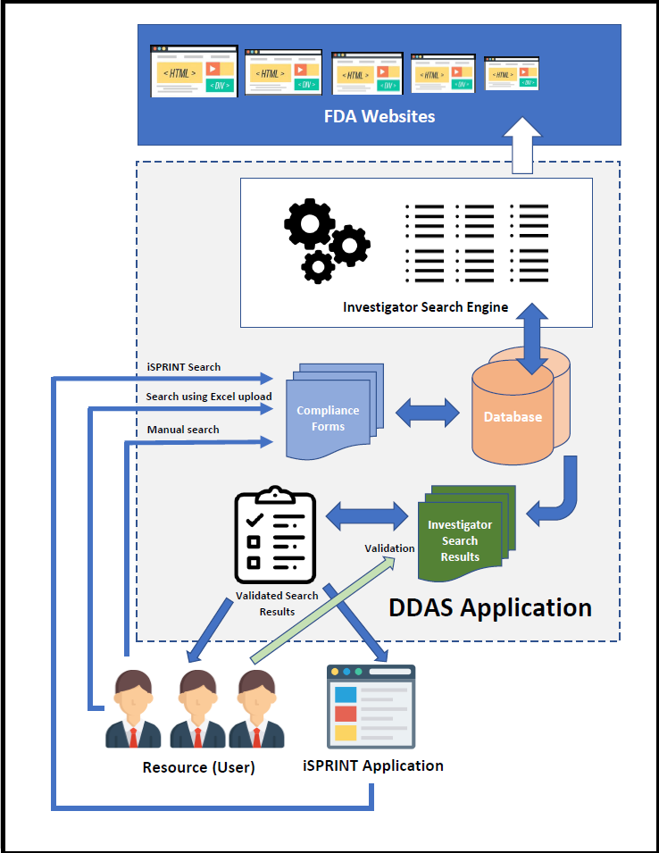

## *Application Servers*

**Web Servers**

|  |  |  |  |  |  |
| --- | --- | --- | --- | --- | --- |
| Function | IP Address | Server Name | Physical Location | Software | Version |
| Prod | 10.11.103.145 | ****** |  | **** | **** |
| Test | 10.11.103.149 |  |  |  |  |

**Folder Structure**

|  |  |
| --- | --- |
| Path | Notes |
| \DataFiles\Attachments | Files attached while requesting QC are saved in this folder |
| \DataFiles\Downloads\CIILFolder | Files extracted for CIIL source are saved |
| \DataFiles\Downloads\ExclusionDatabase | Files extracted for Exclusion database source are saved |
| \DataFiles\Downloads\FDAWarningLetters | Files extracted for FDA Warning Letters source are saved |
| \DataFiles\Downloads\SAM | Files extracted for SAM source are saved |
| \DataFiles\Downloads\SDN | Files extracted for SDN source are saved |
| \DataFiles\Downloads\ErrorScreenCapture | Errors occurred during data extraction process are saved as images. |
| \DataFiles\Downloads\OutputFileFolder | Output files generated by the application are saved in .xlsx format. |
| \DataFiles\Downloads\Templates | Templates used in the application are stored (Input, Output template and user manual) |
| \DataFiles\Downloads\Uploads | Compliance form inputs uploaded using excel template are stored in this folder |

## *Database Servers*

**Database Servers**

**Database Used: MongoDB 3.3.0**

|  |  |  |  |  |  |
| --- | --- | --- | --- | --- | --- |
| Function | IP Address | Server Name | Physical Location | Software | Version |
| Prod | 10.11.103.154 | eu-duedilp-d001 | - | ***** | **** |
| Test | 10.11.103.156 | eu-duedilt-d001 | - | ***** | **** |
| Dev | 10.11.103.156 | eu-duedilt-d001 | - | ***** | **** |

**Database Instances**

|  |  |  |  |
| --- | --- | --- | --- |
| Function | Server | Instance | Notes |
| Prod | eu-duedilp-d001 | ddasprod |  |
| Test | eu-duedilt-d001 | ddastest |  |
| Dev | eu-duedilt-d001 | ddasdevp |  |

## *System Functions and or Services*

**Batch Schedulers**

**Type:** Scheduled Task

**File Path:** bin\DDASDataExtractor.exe

**Frequency:** Scheduled to run at 1 am everyday

**Description:** The scheduled task extracts data from the data sources (refer to Annexure), downloads files and saves data into the database

**Log:** The process is logged in the database and can be viewed by admin under ‘Extraction Logs’

## *Backups/Restores*

Handled by ICON IT

# Support Procedures

## *Common Problems/Troubleshooting*

Data Extraction Errors

Error Logs

## Data Extraction Error:

DDAS application downloads/extracts data from 12 FDA sites every day. The download status of these websites provided in the application is shown below.

Below are the steps the extraction process goes through:

1. Navigate to the site source
2. Read HTML element using page source. Each html element in the page is represented by a tag and its properties. Data from the element is read through these tags. If any of the site source is updated, that is, changes to any of the html elements will cause the extraction process to fail. In such scenario, the application has to be updated to get the required information from the respective site source where the HTML source has changed
3. Download the data file from the identified link and save the file into the folders respective to the site sources, as shown above in section ‘**Folder Structure**’. (Links to download the data files are already identified. *Refer to* ‘Site Sources’ *and* ‘Extraction Method’ *in* **Annexure-1**)
4. For some of the site sources, data is scraped from the web page and is saved into database. For other site sources, the data files are downloaded and the data from the downloaded files is written to database (*refer to* ‘Extraction Method’ *in* ***Annexure-1****)*
5. Success and Error messages during the extraction process are logged in the ‘Extraction Log’
6. In addition to logs, when an error occurs during the extraction process, screen image of the web page at the time of scraping, as it appears is captured and is saved in the ‘ErrorScreenCapture’ folder (*refer to* ‘Folder Structure’ *section above*)

Data Extraction Status is indicated as shown below

**Extractor Indicator**

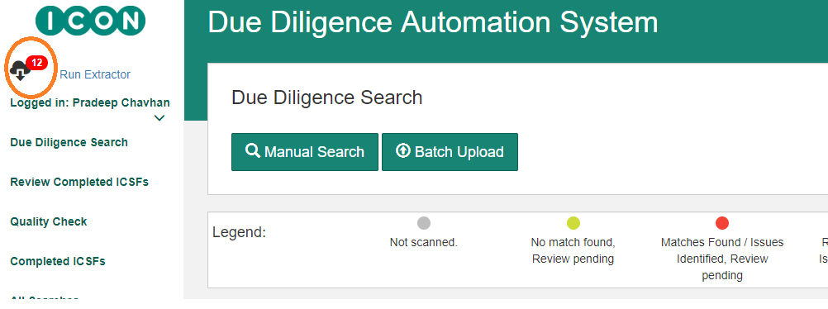

**Data Extractor**

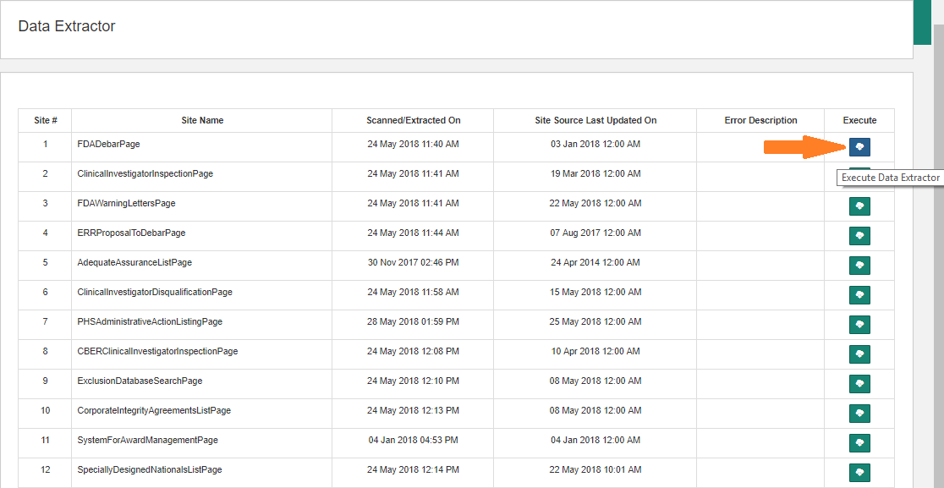

* As indicated in the above screenshot – **Extractor Indicator**, the number of sites for which the data has not been extracted is shown in red colour
* ‘**Run Extractor**’ link nextto the **Extractor Indicator** appears only for admin. This link will navigate to ‘**Data Extractor**’ page (as per the above screenshot ‘**Data Extractor**’)
* As indicated in ‘**Run Extractor**’ page, data can be extracted for any site.
* Success and Failure Messages of extraction process are as shown below

**(On successful data extraction)**

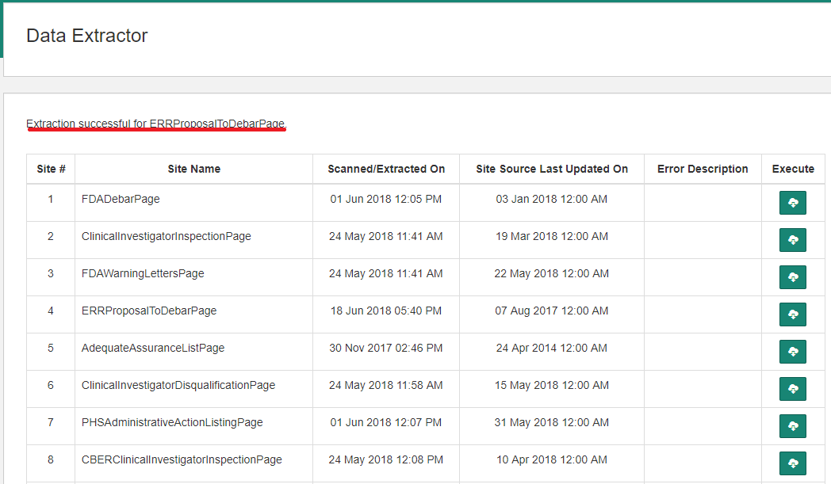

**(On failure)**

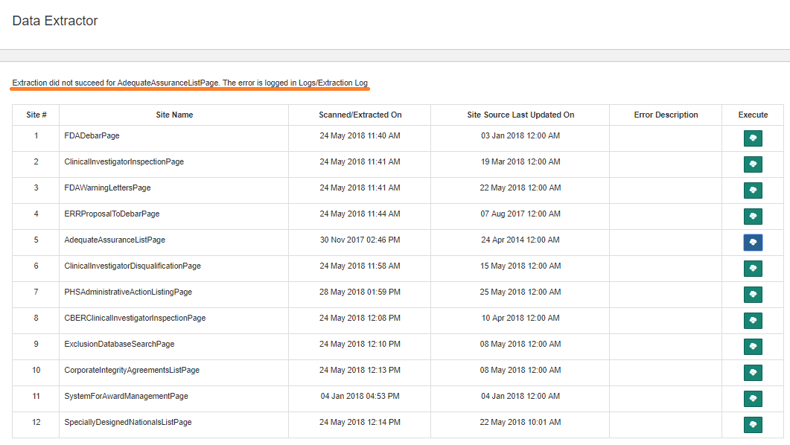

* If extraction fails, navigate to the site through a web browser (refer **Annexture-1**) and check whether the site is accessible
* If the site is not accessible, inform the DDAS team
* If the site is accessible and the extraction has failed, Inform Clarity team

## Error Logs:

User with role ‘Admin’ can view ‘Extraction Log’ and the ‘Error Logs’.

1. **Extraction Log**
   1. Logs related to data extraction process appear in this page
   2. If the data extraction fails for one or more site sources, the ‘Extraction Log’ provides details on the failure of those site sources
   3. Extraction Log also has information on all site sources which have downloaded or scraped the data successfully
2. **Error Logs**
   1. Whenever, an unexpected error occurs or an unhandled bug appears, the error will be captured and will be available in the ‘Error Log’ page
   2. Anytime, a part of the application does not work as expected, this ‘Error Log’ should be checked to see whether any error related to a particular process has been captured
3. **Error Screen Capture**
   1. Screen capture of the errors occurred during extraction process are saved in the folder **\DataFiles\Downloads\ErrorScreenCapture**

# Annexure - 1:

## Site Sources:

Below are the links for the sites for which data extraction is carried out

|  |  |  |
| --- | --- | --- |
| **Serial Number** | **Site Name** | **Site Url** |
| 1 | FDA Debarment List | <http://www.fda.gov/ora/compliance_ref/debar/default.htm> |
| 2 | Clinical Investigator Inspection List (CLIL)(CDER) | <https://www.fda.gov/Drugs/InformationOnDrugs/ucm135198.htm> |
| 3 | FDA Warning Letters and Responses | <https://www.accessdata.fda.gov/scripts/warningletters/wlSearchResultExcel.cfm?qryStr>= |
| 4 | Notice of Opportunity for Hearing (NOOH) – Proposal to Debar | <http://www.fda.gov/RegulatoryInformation/FOI/ElectronicReadingRoom/ucm143240.htm> |
| 5 | Adequate Assurances List for Clinical Investigators | <http://www.fda.gov/ora/compliance_ref/bimo/asurlist.htm> |
| 6 | Clinical Investigators – Disqualification Proceedings (FDA Disqualified/Restricted) | <http://www.accessdata.fda.gov/scripts/SDA/sdNavigation.cfm?sd=clinicalinvestigatorsdisqualificationproceedings&previewMode=true&displayAll=true> |
| 7 | Clinical Investigator Inspection List (CBER) | <http://www.fda.gov/BiologicsBloodVaccines/GuidanceComplianceRegulatoryInformation/ComplianceActivities/ucm195364.htm> |
| 8 | PHS Administrative Actions Listing | <https://ori.hhs.gov/ORI_PHS_alert.html?d=update> |
| 9 | HHS/OIG/ EXCLUSIONS DATABASE SEARCH/ FRAUD | <https://oig.hhs.gov/exclusions/exclusions_list.asp> |
| 10 | HHS/OIG Corporate Integrity Agreements/Watch List | <http://oig.hhs.gov/compliance/corporate-integrity-agreements/cia-documents.asp> |
| 11 | SAM/SYSTEM FOR AWARD MANAGEMENT | <https://www.sam.gov/portal/public/SAM> |
| 12 | LIST OF SPECIALLY DESIGNATED NATIONALS | <http://www.treasury.gov/resource-center/sanctions/SDN-List/Pages/default.aspx> |

## Extraction Method:

|  |  |  |
| --- | --- | --- |
| **Site Number** | **Sites** | **Extraction Type** |
| 1 | FDA Debarment List | Scraping |
| 4 | Notice of Opportunity for Hearing (NOOH) – Proposal to Debar |
| 5 | Adequate Assurances List for Clinical Investigators |
| 6 | Clinical Investigators – Disqualification Proceedings (FDA Disqualified/Restricted) |
| 7 | Clinical Investigator Inspection List (CBER) |
| 8 | PHS Administrative Actions Listing |
| 10 | HHS/OIG Corporate Integrity Agreements/Watch List |
| 2 | Clinical Investigator Inspection List (CLIL)(CDER) | File Download |
| 3 | FDA Warning Letters and Responses |
| 9 | HHS/OIG/ EXCLUSIONS DATABASE SEARCH/ FRAUD |
| 11 | SAM/SYSTEM FOR AWARD MANAGEMENT |
| 12 | LIST OF SPECIALLY DESIGNATED NATIONALS |

## Site Source Details:

## 1. FDA Debarment List

Data File Downloaded: No

Contents in the table indicated below are extracted and saved into database

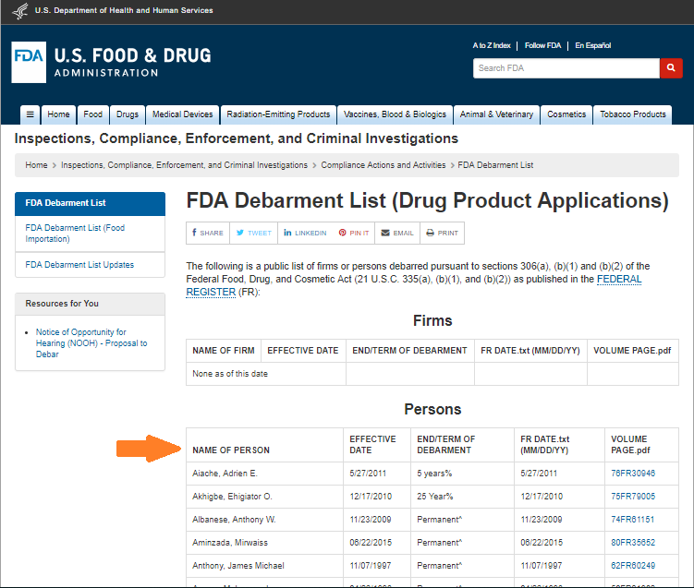

## 2. Clinical Investigator Inspection List (CLIL)(CDER)

Data File Downloaded: Yes

Data file is downloaded from the link indicated below and the data is saved into database

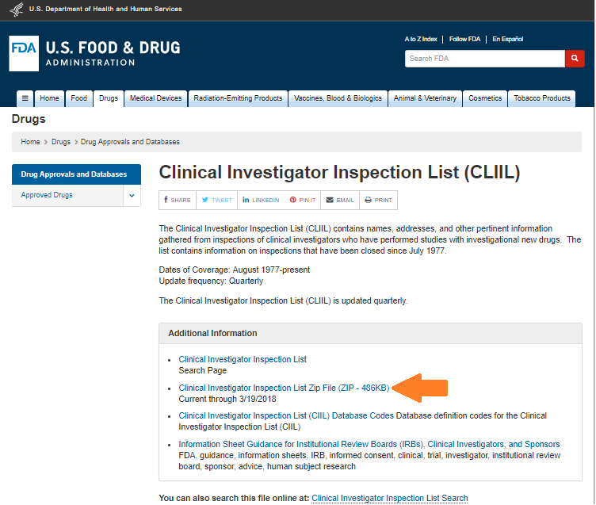

## 3. FDA Warning Letters and Responses

Data File Downloaded: Yes

The given link directly downloads the file. Data is then saved into database

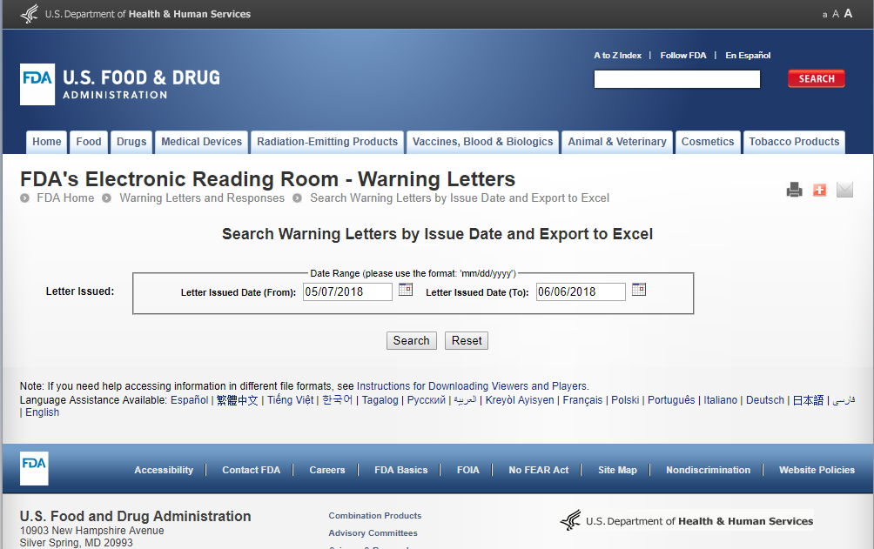

## 4. Notice of Opportunity for Hearing (NOOH) – Proposal to Debar

Data File Downloaded: No

Contents in the table indicated below are extracted and saved into database

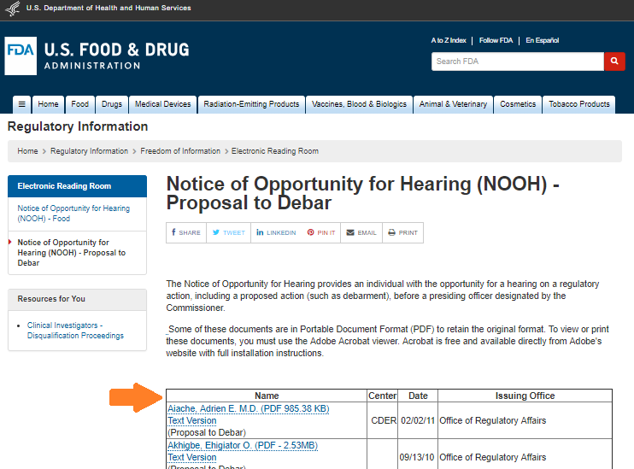

## 5. Adequate Assurances List for Clinical Investigators

Data File Downloaded: No

Currently this site is down

## 6. Clinical Investigators – Disqualification Proceedings (FDA Disqualified/Restricted)

Data File Downloaded: No

Contents in the table indicated below are extracted and saved into database

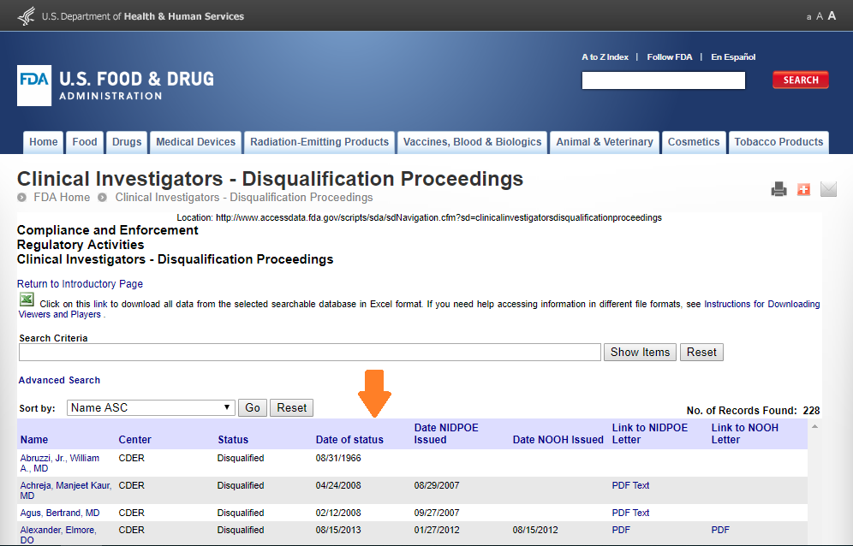

## 7. Clinical Investigator Inspection List (CBER)

Data File Downloaded: No

Contents in the table indicated below are extracted and saved into database

Data is extracted for all the lists: A-D, E-K, L-P, Q-S and T-Z

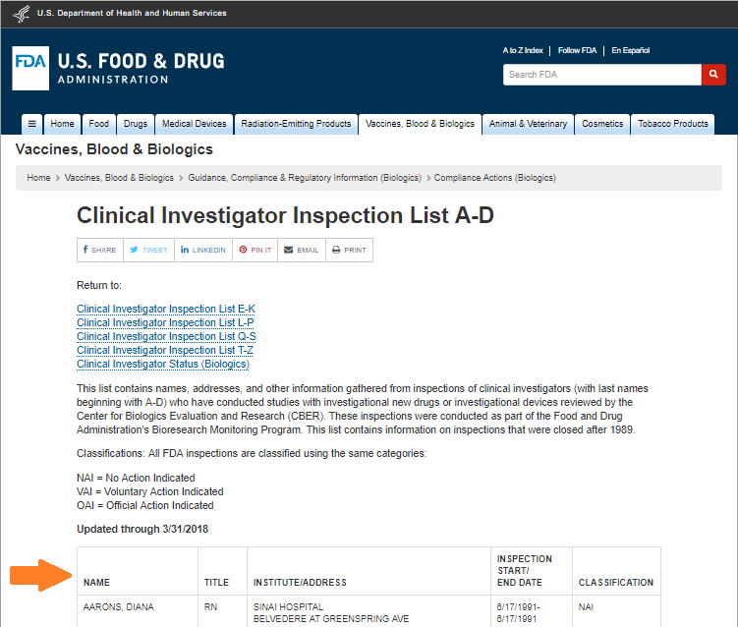

## 8. PHS Administrative Actions Listing

Data File Downloaded: No

Contents in the table below are extracted and saved into database

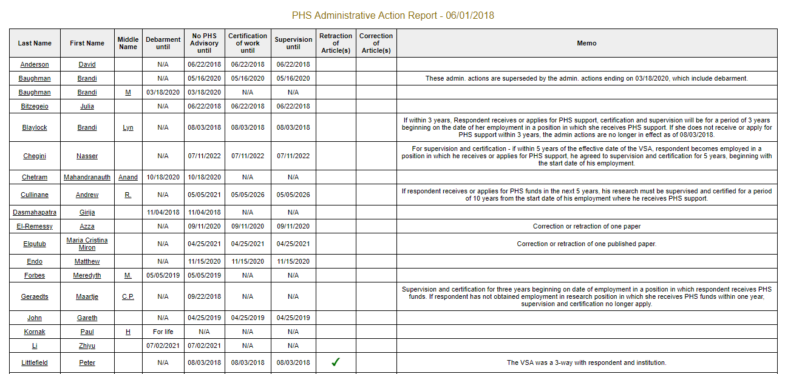

## 9. HHS/OIG/ EXCLUSIONS DATABASE SEARCH/ FRAUD

Data File Downloaded: Yes

Data file is downloaded from the link indicated below and the data is saved into database

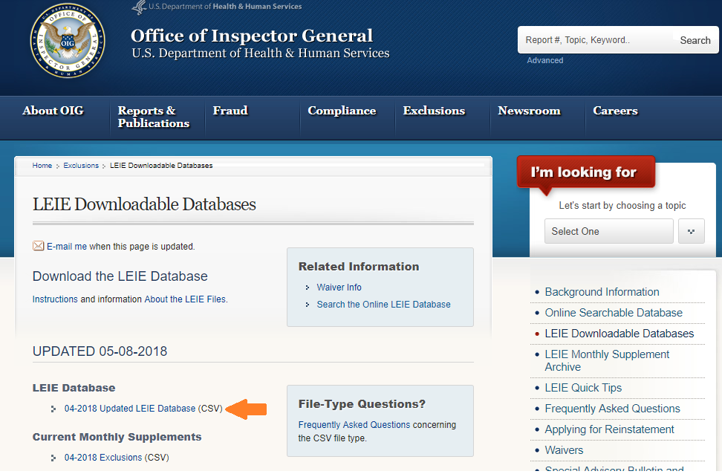

## 10. HHS/OIG Corporate Integrity Agreements/Watch List

Data File Downloaded: No

Contents in the table indicated below are extracted and saved into database (From A to Z)

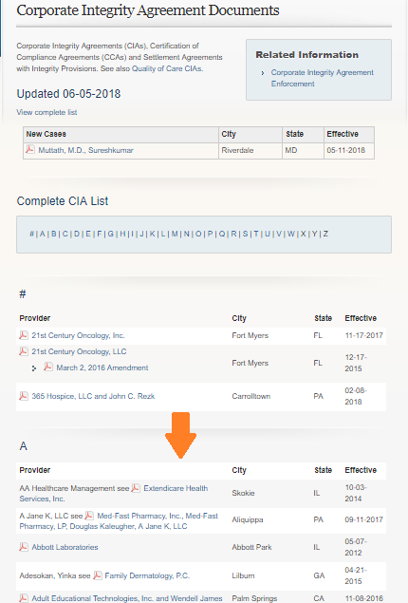

## 11. SAM/SYSTEM FOR AWARD MANAGEMENT

Data File Downloaded: Yes

Below is the Home Page

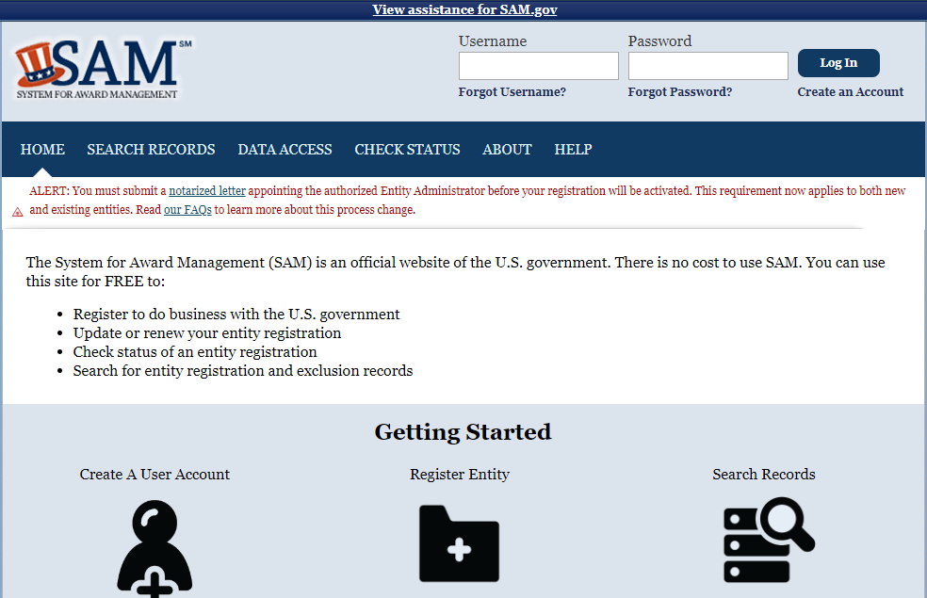

Navigate to the ‘DATA ACCESS’ page. At the bottom of the page, ‘Exclusion Extract Data Package’ table is displayed, as shown below. This table contains past 7 days files of exclusion extract lists. Download the last file to get the most recent exclusion extract data as shown below

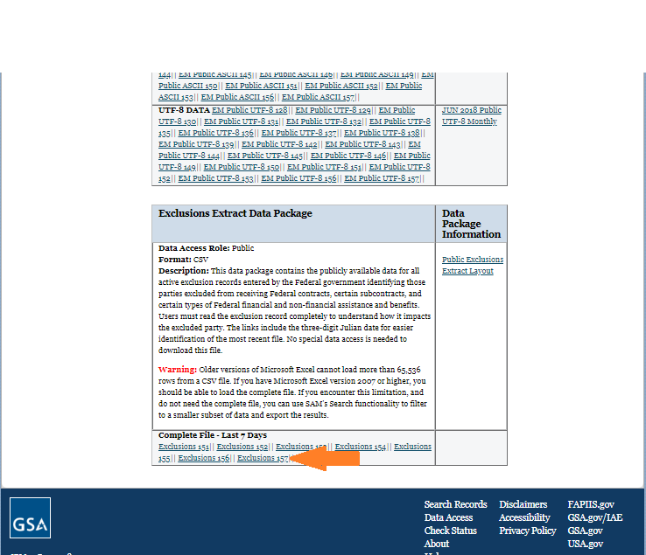

## 12. LIST OF SPECIALLY DESIGNATED NATIONALS

Data File Downloaded: Yes

Data file is downloaded from the link indicated below and the data is saved into database

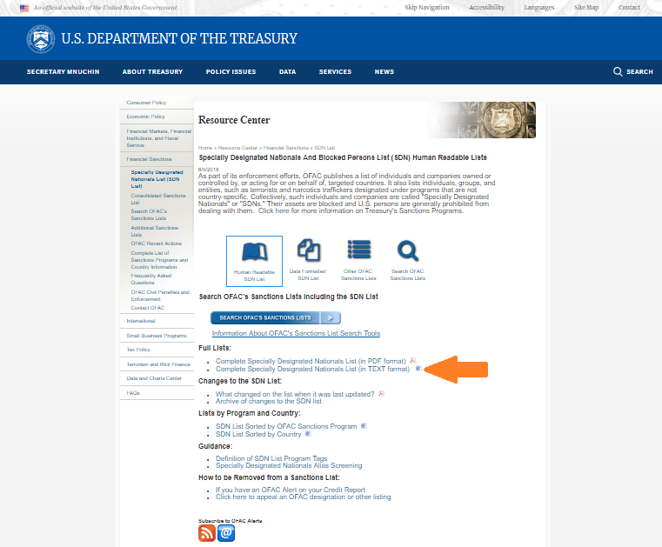

# Data Structures

## Compliance Form Data Structure

Compliance Form

|--Project Number, Sponsor Protocol Number, Institute, Address

|--Investigators

|----Sites Searched

|--Site Sources

|--Findings

*UI = User input, AG = Application Generated

|  |  |  |  |  |  |
| --- | --- | --- | --- | --- | --- |
| Field Name | Data Type | Size | *UI / AG | Validations | Comments |
| Project Number | text | 9 | UI | Required, dddd/dddd (1234/1234) |  |
| SponsorProtocolNumber | text | 100 | UI | none |  |
| Institute | text | 100 | UI | none |  |
| Address | text | 500 | UI | none |  |
| Country | text | 100 | UI | none |  |
| AssignedTo | text | - | AG | none |  |
| SearchStartedOn | date | - | AG | none |  |
| UploadedFileName | text | - | AG | none |  |
| ExtractedOn | date | - | AG | none |  |
| FullMatchesFoundInvestigatorCount | number | - | AG | none |  |
| PartialMatchesFoundInvestigatorCount | number | - | AG | none |  |
| SingleMatchFoundInvestigatorCount | number | - | AG | none |  |
| IssuesFoundInvestigatorCount | number | - | AG | none |  |
| ReviewCompletedInvestigatorCount | number | - | AG | none |  |
| Investigators | Collection | Min: 1, Max: no limit | UI | none |  |
| |  |  |  |  |  |  | | --- | --- | --- | --- | --- | --- | | Field Name | Data Type | Size | UI/AG | Validations | Comments | | Name | text | 100 | UI | Required |  | | First Name | text | 25 | UI | Any two fields First, Middle or Last are required |  | | Middle Name | text | 25 | UI |  | | Last Name | text | 25 | UI |  | | Role | text | 50 | AG | Values: Principal / Sub |  | | Qualification | text | 50 | UI | none |  | | Medical Licese Number | text | 50 | UI | none |  | | InvestigatorId | text | 50 | UI | none |  | | MemberId | text | 50 | UI | none |  | | Sites_FullMatchCount | number | - | AG | none |  | | Sites_PartialMatchCount | number | - | AG | none |  | | Sites_SingleMatchCount | number | - | AG | none |  | | IssuesFoundSiteCount | number | - | AG | none |  | | ReviewCompletedSiteCount | number | - | AG | none |  | | Sites Searched | Collection |  | AG | none |  | | |  |  |  |  |  |  | | --- | --- | --- | --- | --- | --- | | Field Name | Data Type | Size | UI/AG | Validations | Comments | | Site Id | text | 128 | AG |  |  | | FullMatchCount | number | - | AG |  |  | | PartialMatchCount | number | - | AG |  |  | | SingleMatchCount | number | - | AG |  |  | | IssuesFound | number | - | AG |  |  | | ExtractionMode | Text, value: ‘Manual’, ‘DB’ | - | AG |  |  | | | | | | | | | | | | |
| Site Sources | Collection | - | AG | - |  |
| |  |  |  |  |  |  | | --- | --- | --- | --- | --- | --- | | Field Name | Data Type | Size | UI/AG | Validations | Comments | | Display Position | number |  | AG |  |  | | SiteName | text |  | AG |  |  | | SiteUrl | text |  | AG |  |  | | Extraction Mode | text |  | AG |  |  | | SiteSourceUpdatedOn | number |  | AG |  |  | | SearchAppliesTo | number |  | AG |  |  | | IssuesIdentified | number |  | AG |  |  | | | | | | |
| Findings | Collection | Min: 0, Max: no upper limit | AG |  |  |
| |  |  |  |  |  |  | | --- | --- | --- | --- | --- | --- | | Field Name | Data Type | Size | UI/AG | Validations | Comments | | SiteId | text | 128 | AG |  |  | | InvestigatorName | text |  | AG |  |  | | IsMatchedRecord | Yes/No |  | AG |  |  | | RecordDetails | text |  | AG |  |  | | Observation | text |  | AG |  |  | | IsAnIssue | Yes/No |  | AG |  |  | | Links | Collection |  | AG |  |  | | | | | | |
|  |  |  |  |  |  |

1. Test Foot Note